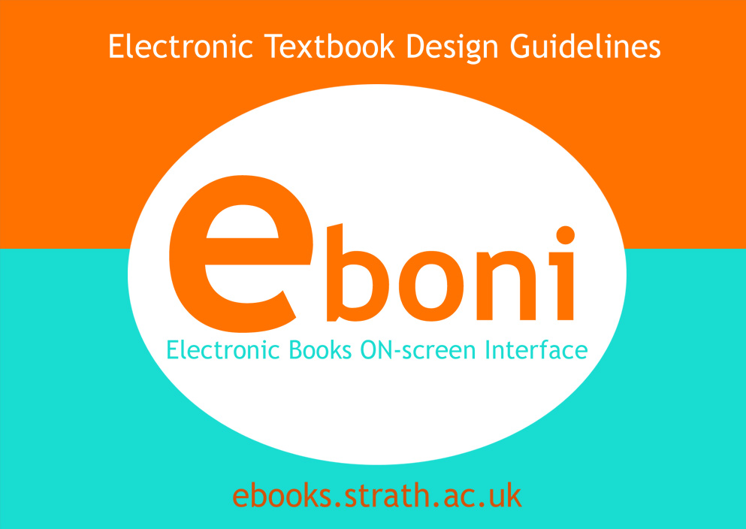 |  | EBONI Electronic Textbook Design Guidelines  23 March 2002  Ruth Wilson and Monica Landoni, Department of Computer and Information Science, University of Strathclyde, UK

N.B. For best results, the guidelines should be printed in colour



Table of Contents

Contents | Page
i. Acknowledgements | 3
ii. List of illustrations | 4
iii. Introduction | 5
iv. On-screen design guidelines | 8
Guideline 1: Cover your book | 8
Guideline 2: Include a table of contents | 10
Guideline 3: Include an index | 12
Guideline 4: Provide a search tool | 13
Guideline 5: Treat the book as a closed environment | 15
Guideline 6: Use hypertext to enhance navigation and facilitate cross-referencing | 17
Guideline 7: Design typographical aspects carefully | 20
Guideline 8: Use short pages | 21
Guideline 9: Provide content clues | 24
Guideline 10: Provide orientation clues | 26
Guideline 11: Choose a readable font | 29
Guideline 12: Use colour to create a consistent style and aid scannability | 30
Guideline 13: Break text into short chunks | 32
Guideline 14: Use non-text items with care | 33
Guideline 15: Use multimedia and interactive elements to engage users | 35
Guideline 16: Provide bookmarking and annotating functions | 38
Guideline 17: Enable customisation | 39
v. Hardware design guidelines | 41
Guideline 18: Employ high quality display technology | 41
Guideline 19: Balance lightness and portability against legibility | 43
Guideline 20: Design devices for comfort | 44
Guideline 21: Use buttons and dials to improve page turning | 46
Guideline 22: Make devices robust | 49
vi. Index | 51
vii. Bibliography | 53

- Acknowledgements
Many thanks to Julie Shortreed and Joan Dunn who conducted evaluations which informed these guidelines as part of their MSc dissertations in the Department of Information Science, University of Strathclyde.
Thanks also to Cliff McKnight, Keith van Rijsbergen, Robin Timmons, Leonard Hamilton, Peter Kaiser, Eric Chudler and John Suler who provided material for evaluation and gave permission to use screenshots of their books to illustrate the guidelines, and to Palm, Hewlett-Packard, Franklin and Gemstar for permission to use images of their handheld devices.

- Illustrations
Figure | Title | Page
Figure 1.1 | E-textbook cover: The Joy of Visual Perception by Peter Kaiser | 9
Figure 1.2 | E-textbook cover: Hypertext in Context by Cliff McKnight, Andrew Dillon and John Richardson | 10
Figure 2 | Table of contents: Drugs, Brains and Behaviour by Robin Timmons and Leonard Hamilton | 11
Figure 3 | Index: The Joy of Visual Perception by Peter Kaiser | 13
Figure 4.1 | Search tool: Neuroscience for Kids by Eric Chudler | 14
Figure 4.2 | Search tool: The Psychology of Cyberspace by John Suler | 15
Figure 5 | Mix of internal and external links: The Joy of Visual Perception by Peter Kaiser | 16
Figure 6 | Use of hypertext: Hypertext in Context by Cliff McKnight, Andrew Dillon and John Richardson, redesigned by Joan Dunn | 19
Figure 7 | Example of clear layout: Information Retrieval by Keith van Rijsbergen, redesigned by Ruth Wilson | 21
Figure 8 | Short pages: Hypertext in Context by Cliff McKnight, Andrew Dillon and John Richardson, redesigned by Joan Dunn | 23
Figure 9 | Content summary: Drugs, Brains and Behaviour by Robin Timmons and Leonard Hamilton | 25
Figure 10.1 | Orientation clues: The Visual Book | 27
Figure 10.2 | Orientation clues: Hypertext in Context by Cliff McKnight, Andrew Dillon and John Richardson, redesigned by Joan Dunn | 28
Figure 11 | Readable font: Neuroscience for Kids by Eric Chudler | 30
Figure 12 | Consistent style: Information Retrieval by Keith van Rijsbergen, redesigned by Ruth Wilson | 31
Figure 13 | Text broken into short chunks: Neuroscience for Kids by Eric Chudler | 33
Figure 14.1 | Use of images: Neuroscience for Kids by Eric Chudler | 34
Figure 14.2 | Use of formulae: Information Retrieval by Keith van Rijsbergen, redesigned by Ruth Wilson | 35
Figure 15.1 | Use of interactive elements: Neuroscience for Kids by Eric Chudler | 37
Figure 15.2 | Use of interactive elements: The Joy of Visual Perception by Peter Kaiser | 38
Figure 16 | Bookmarking and annotating functions: The Visual Book | 39
Figure 17 | Microsoft Reader, available on the Hewlett-Packard Jornada 548, enables manipulation of font sizes | 40
Figure 18 | High quality display technology: Hewlett-Packard Jornada 548 | 42
Figure 19 | Large, heavier device: REB 1200 | 44
Figure 20 | Designed for comfort: Hewlett-Packard Jornada 548 | 45
Figure 21.1 | Buttons for page turning: REB 1100 | 47
Figure 21.2 | Dial for page turning: Franklin's eBookMan | 48
Figure 22 | Robust device: Franklin's eBookMan | 50
- Introduction
Scope and purpose
The need for best practice guidelines for the design of electronic textbooks arose from the growing availability of learning and teaching material for Higher Education in electronic format, to which students are increasingly turning as a first port of call when seeking material to support their studies. With initiatives such as the National Grid for Learning and The People's Network improving the flow of online material, it is timely to pay attention to the internal design of the resources themselves so that, once accessed, the required data can be retrieved as quickly and easily as possible.
Several other sets of guidelines exist for designing electronic resources (e.g. Jakob Nielsen’s Designing Web Usability and Peter Muller’s Writing Hypertext Books). EBONI's Electronic Textbook Design Guidelines, however, provide advice on preparing material for a specific audience of academics and students in Higher Education, and incorporate this audience’s special requirements. As such, they are of use to:
• Writers and publishers of scholarly digital information
• Lecturers in HE
• Information professionals
• Agencies which invest in the creation of scholarly digital resources
• Electronic book hardware and software developers
• Projects and services involved in the digitisation of learning and teaching resources
The on-screen design guidelines are primarily intended to be applied to books published on the Web, but the principles will be relevant to ebooks of all descriptions and, in certain cases (e.g. Guideline 16: Provide bookmarking, highlighting and annotating functions), it is possible that only commercial ebook software companies will have the resources to comply at their disposal. They simply reflect the results of our user evaluations, and it is recognised that they will be implemented at different levels by different content developers.
It is important to note that the guidelines are not intended to establish a strict uniformity of interface for all electronic learning and teaching resources, but rather to encourage use of those styles and techniques which are most successful in terms of usability.
Evaluations
The guidelines have been formed as a result of extensive evaluations of electronic books involving around 100 students, lecturers and researchers from a range of disciplines in UK Higher Education. These include:
• The WEB Book experiment, which focused on the impact of appearance on the usability of textbooks on the Web. Two electronic versions of the same chapter, one in a very plain scrolling format, the other made more "scannable" according to John Morkes and Jakob Nielsen’s Web design guidelines, were selected as the material for evaluation, and the scannable text proved to be 92% more usable.
• An evaluation of three textbooks in psychology, all of which have been published on the Internet by their authors and are available free of charge. These textbooks differ markedly in their appearance, and the study aimed to find which styles and techniques are most effective in enabling students to find the information they require, and to record students' subjective satisfaction with each book.
• An evaluation of Hypertext in Context by Cliff McKnight, Andrew Dillon and John Richardson. This textbook was compared in three formats: print, the original electronic version on the Web, and a second electronic version, revised according to Morkes and Nielsen's scannability guidelines. Experiment conducted by Joan Dunn.
• A comparison of three electronic encyclopaedias: Encyclopaedia Britannica, The Columbia Encyclopaedia and Encarta. Experiment conducted by Julie Shortreed.
• A comparison of a title in geography (New Frontiers of Space, Bodies and Gender by Rosa Ainley) which is available in three electronic formats: MobiPocket Reader, Adobe Acrobat Ebook Reader and Microsoft Reader.
• A study into usability issues surrounding portable electronic books. Five devices were evaluated by lecturers and researchers with the aim of determining which physical design elements enhance and which detract from the experience of reading or consulting an electronic book.
A specially developed "Ebook Evaluation Model" was implemented in varying degrees by each of these experiments, ensuring that all results could be compared at some level. This methodology comprised various options for selecting material and participants and described the different tasks and evaluation techniques which can be employed in an experiment. These ranged from simple retrieval tasks measuring the participants' ability to find information in the material to "high cognitive skill" tasks set by lecturers to measure the participants' understanding of concepts in the texts, and from Web-based questionnaires measuring subjective satisfaction to one-to-one interviews with participants discussing elements of interacting with the test material in detail.
Arrangement of the guidelines
EBONI's Electronic Textbook Design Guidelines address two main factors affecting ebook interface design:
• The on-screen appearance of information
• The look and feel of ebook hardware
The first fifteen guidelines focus on on-screen design issues, while the remainder advise on hardware design. Each guideline has a number, a title, a brief description, a list of checkpoints with which developers of digital textbooks should comply in order to maximise the usability of their content for the HE community, and examples are included to illustrate aspects of good practice.
Where appropriate, the W3C Web Content Accessibility Guidelines are referred to. Developers of online content should comply with these to ensure material is available to the widest possible audience, and should also refer to the following publications:
• The W3C User Agent Accessibility Guidelines 1.0
• The W3C HTML 4.0 Guidelines for Mobile Access (work in progress)
• DAISY Digital Talking Book 2.02 Specification
• The Open eBook Forum Publication Structure 1.0.1

On-screen design guidelines
The importance of appearance in the design of ebooks was the subject of the Visual Book and WEB Book experiments, with two main themes emerging as fundamental to usability:
• The legacy of the paper book metaphor, and the wisdom of adhering to this, where appropriate, in the construction of the electronic book.
• The different set of requirements arising when the reader interacts with the new medium; in particular, the effectiveness of presenting material electronically in short, scannable chunks rather than a long, linear flow of text.
EBONI's students have confirmed these findings, with the following guidelines emerging:

Guideline 1: Cover your book
“An interesting cover… can add to the enjoyment of reading a book. The ebook which I read was only able to provide the textual element of reading a book”
Participant in EBONI hardware evaluation
Although of no practical value in an electronic environment, the inclusion of a textbook "cover" adds to the enjoyment of the reading experience, reinforcing the user's perception that he is reading a unique set of pages which form a cohesive unit, and providing a point of recognition on return visits to the book. If the textbook has a paper counterpart, the cover should resemble the cover of the paper book. If the textbook does not have a paper counterpart, a colour illustration should be used, together with the title and author’s name. In both cases, a prominent link should be provided to the table of contents. The cover should comprise one page and fit in one screen; scrolling should not be required.
Checkpoints
1.1 Create a cover page, citing author and title
1.2 Add a link from the cover page to the table of contents
Examples
This image was used to represent the cover of The Joy of Visual Perception:
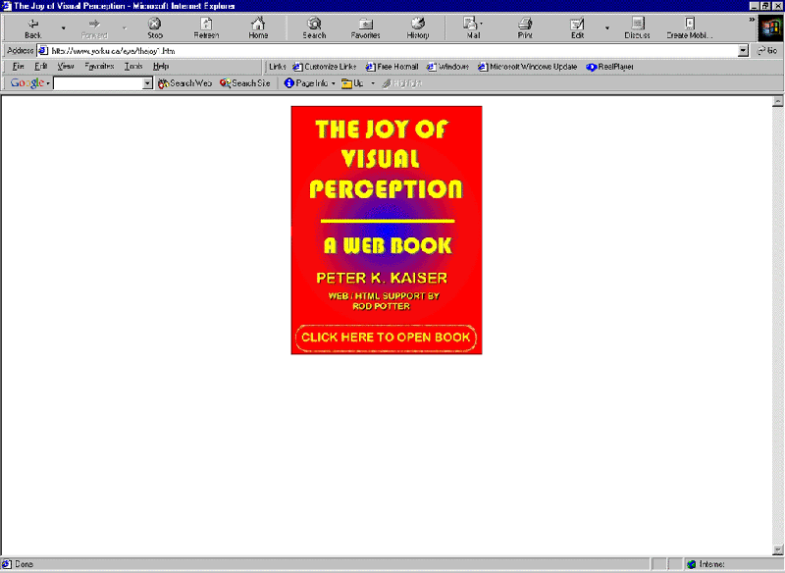
Figure 1.1. E-textbook cover: The Joy of Visual Perception by Peter Kaiser
In Hypertext in Context, a cover page was created based on a scanned image of the paper book:
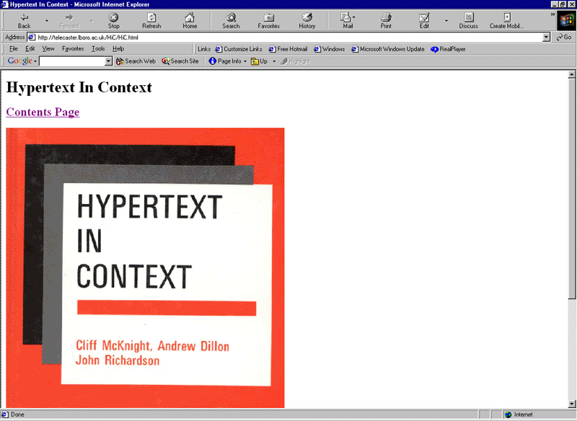
Figure 1.2. E-textbook cover: Hypertext in Context by Cliff McKnight, Andrew Dillon and John Richardson

Guideline 2: Include a table of contents
“I couldn’t find what I was looking for. The contents page was unhelpful”
Participant in EBONI geography evaluations
While search facilities provide a powerful method of hunting through an electronic textbook for information (see Guideline 4), they should not simply replace tables of contents and indexes. Tables of contents are an essential feature in both print and electronic media, used by readers to skim the contents of an unfamiliar book to gain an idea of what can be found inside. They also provide the reader with a sense of structure, which can easily be lost in the electronic medium, and can be an important navigation tool where hypertext is used to link from the table of contents to individual chapters.
Care should be taken to use meaningful chapter headings to help guide the reader to relevant content. Additional clues as to the content of each chapter may also be included (see Guideline 9).
Checkpoints
2.1 Include a table of contents
2.2 Create hyperlinks from the table of contents to individual chapters and sections
2.3 Use meaningful chapter headings
Accessibility considerations
Consult the following recommendation from the W3C Web Content Accessibility Guidelines 1.0:
- Guideline 13: Provide clear navigation mechanisms
Example
The table of contents for Drugs, Brains and Behaviour, with hyperlinks to each chapter:
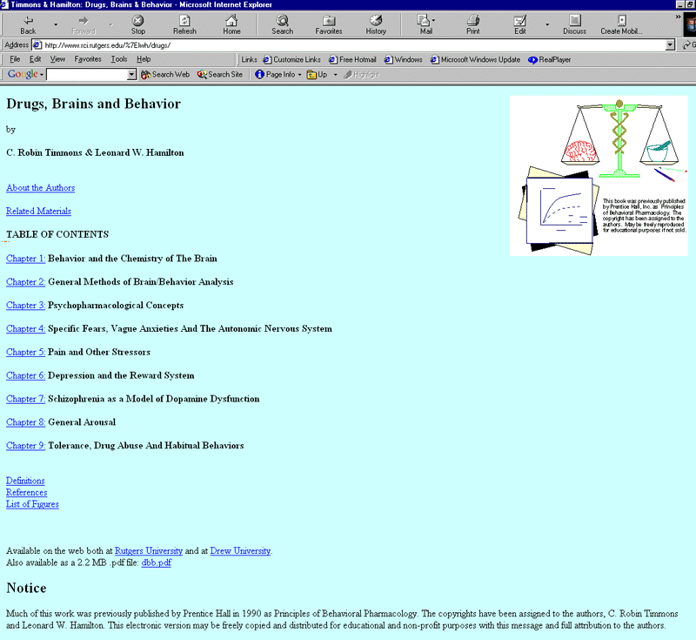
Figure 2. Table of contents: Drugs, Brains and Behaviour by Robin Timmons and Leonard Hamilton

Guideline 3: Include an index
“Indexes are really useful, but it was really hard to find”
Participant in EBONI geography evaluations
An index helps readers to find information on a specific topic within a book. By including hyperlinks from each index item to the relevant section in the book, it can become an important navigation tool, and should be made prominent (unlike in printed books, where indexes are traditionally found at the back).
Checkpoints
3.1 Include an alphabetical index
3.2 Create hyperlinks from index items to relevant sections of the book
3.3 Make the index prominent
Accessibility considerations
Consult the following recommendation from the W3C Web Content Accessibility Guidelines 1.0:
- Guideline 13: Provide clear navigation mechanisms
Example
A section of the index to The Joy of Visual Perception, with hyperlinks to relevant sections in the book:
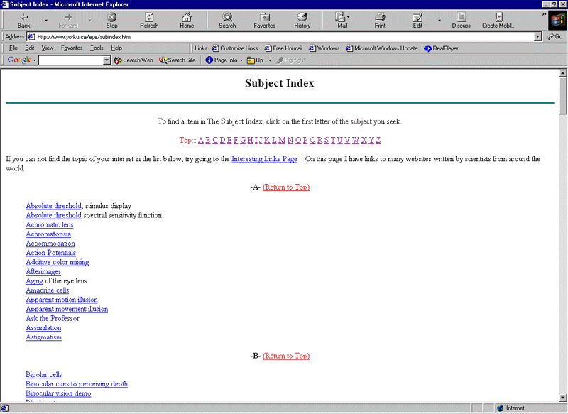
Figure 3. Index: The Joy of Visual Perception by Peter Kaiser

Guideline 4: Provide a search tool
“A better search interface with more advanced methods of your query would have improved the whole experience for me”
Participant in EBONI encyclopaedia evaluation
Tables of contents and indexes both offer access points for browsing. These can be supplemented by search tools which provide another method of finding information in an electronic text, and are appreciated by readers (especially readers of reference material such as encyclopaedias). They should not replace tables of contents and indexes, and should be intelligent enough to simulate and enhance the way readers search in paper books. A choice between simple searches (searching the whole book, a chapter or a page for a keyword), and advanced searches should be offered to suit different levels of reader. Search tips should be provided.
Checkpoints
4.1 Provide an intelligent search tool to supplement tables of contents and indexes
4.2 Offer simple and advanced search options
Examples
Neuroscience for Kids provides a simple method of searching its pages, with the options to look for a phrase, stem words, and find words that match the case used in the search box:
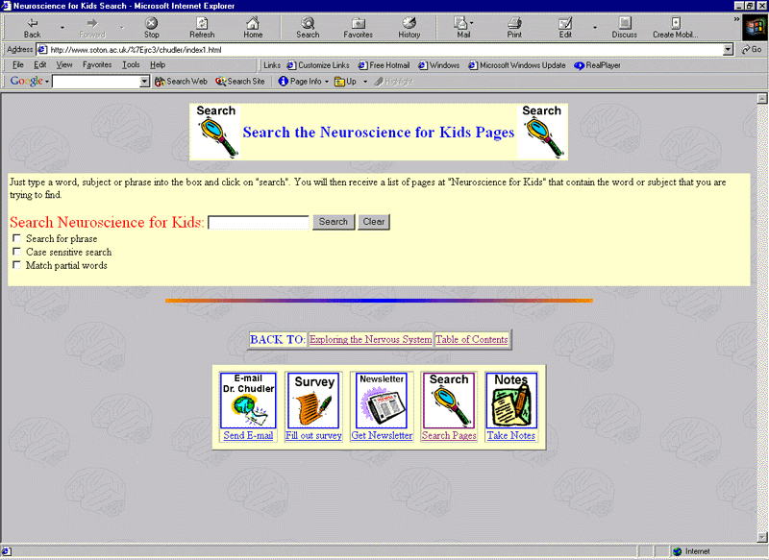
Figure 4.1. Search tool: Neuroscience for Kids by Eric Chudler
The Psychology of Cyberspace offers a basic search tool in addition to its table of contents and index:
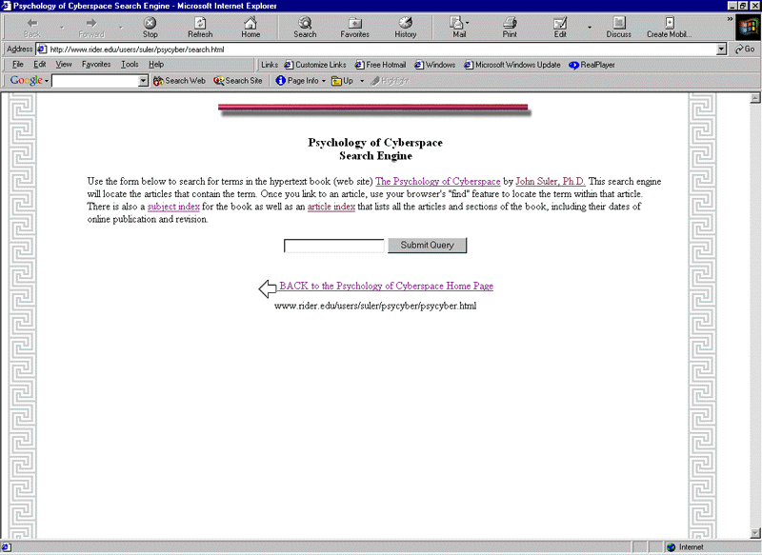
Example 4.2. Search tool: The Psychology of Cyberspace by John Suler

Guideline 5: Treat the book as a closed environment
“I kept getting lost and straying into other parts of the Web”
Participant in EBONI psychology experiment
An electronic book should be treated as a closed environment, containing no links to external sources unless clearly labeled (for example in a reference section or bibliography). This assists the user in understanding the book as a single unit, avoids confusion about which pages are part of the book, and which are part of another resource, and prevents readers from getting “lost” in cyberspace.
Checkpoints
5.1 Do not include external links in the main body of the text
5.2 If external links are provided in the reference section or bibliography, these should be clearly labeled as linking to external sources.
Accessibility considerations
Consult the following recommendations from the W3C Web Content Accessibility Guidelines 1.0:
- Guideline 12: Provide context and orientation information
- Guideline 13: Provide clear navigation mechanisms
Example
In The Joy of Visual Perception, external links are mixed together with internal links. Although indicated as such, readers who are quickly scanning the text may easily become lost.
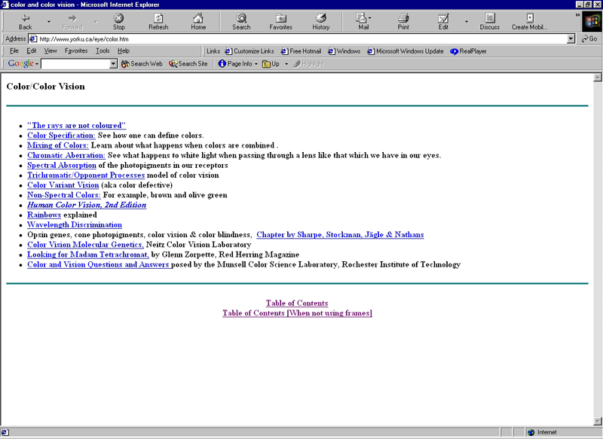
Figure 5. Mix of internal and external links: The Joy of Visual Perception by Peter Kaiser

Guideline 6: Use hypertext to enhance navigation and facilitate cross-referencing
“I was not attracted to [the book’s] navigation. I felt it was difficult and confusing”
Participant in EBONI pilot experiment
Cross-referencing between the pages of a book, between the main text and table of contents, index, footnotes, glossary or references, and between two or more books is considered an important property of the printed medium. Readers strongly value the ability to achieve these cross-referencing tasks in an electronic environment. This can be difficult to achieve with the same simplicity and effectiveness as flicking through paper pages, but can be made more possible in an electronic book by adopting a strong structure and a clear and simple navigation system. The functionality provided by browsers (e.g. “Back”, “Forward”) is very basic and should not be relied on.
Incorporation of hypertext to link between structural elements of a book can greatly improve navigation. These guidelines recommend dividing a chapter into several pages in order to minimise scrolling; hyperlinked tables of contents for chapters can help users decide on the relevance of each chapter at a glance and makes it easier to find information on specific topics. It should be possible to move from one page to the next or previous page quickly and easily. Standard link colours should be used and the functions of any navigation icons should be explicit.
Checkpoints
6.1 Create a strong overt structure
6.2 Provide a clear navigation system
6.3 Separate references from the main text
6.4 Separate glossary from the main text
6.5 Use hypertext to link:
- from the table of contents to individual chapters
- from index items to relevant sections of the book and back to the appropriate section of the main text
- from the main text to references and back to the appropriate section of the main text
- from the main text to the glossary (where available)
- between the pages of a book (e.g. “page forward/page back”) and from each page to browsing and searching tools (table of contents, index and search engine)
6.6 Create tables of contents for individual chapters
6.7 Use standard link colours
6.8 If using icons, make them easy to interpret
6.9 Do not rely on the functionality of a browser
Accessibility considerations
Consult the following recommendations from the W3C Web Content Accessibility Guidelines 1.0:
- Guideline 1: Provide equivalent alternatives to auditory and visual content (including navigation icons)
- Guideline 13: Provide clear navigation mechanisms
Example
This chapter of Hypertext in Context, redesigned for EBONI’s evaluations, uses hypertext to link between the main text and the glossary and references, and between the pages of the book.
At the top of each page are links to the table of contents for the chapter and to a sitemap. At the bottom of each page, links are provided to all the other pages in the chapter.
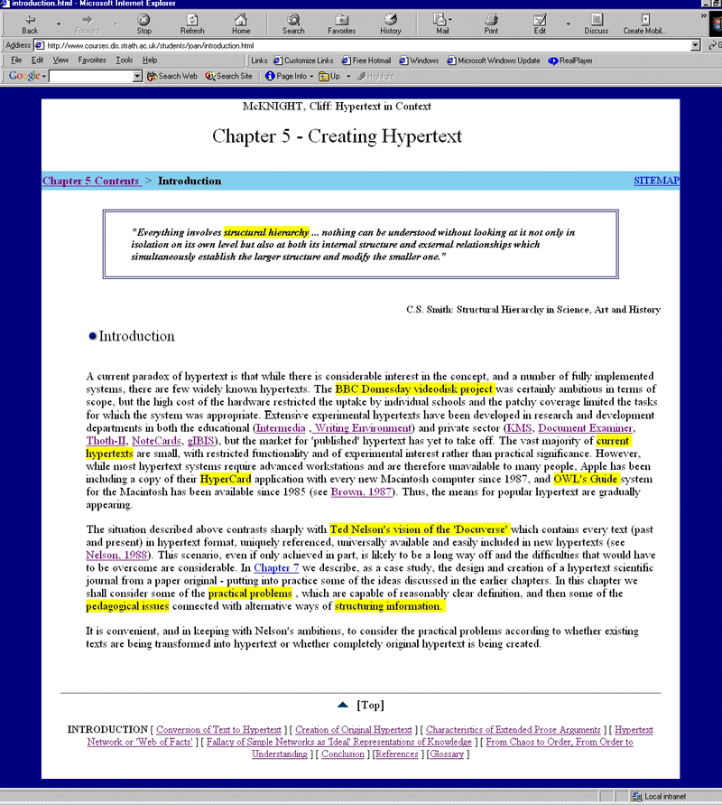
Figure 6. Use of hypertext: Hypertext in Context by Cliff McKnight, Andrew Dillon and John Richardson, redesigned by Joan Dunn

Guideline 7: Design typographical aspects carefully
“Sometimes a bit busy. A lot of stuff was on the screen at any one time, not great if in a hurry”
Participants in EBONI psychology evaluation
Readers expect the typographical sophistication of the printed page, and pagination has to be designed carefully to enhance readability. Line lengths similar to that of the printed page (10 to 15 words) are preferred, punctuated with plenty of white space to give each page a clean, uncluttered appearance. Paragraphs should be left-justified, providing a uniform starting point for each line and enabling the reader to scan the text effectively. The typographical style should be consistent throughout the book.
Checkpoints
7.1 Include plenty of white space to provide page borders
7.2 Use line lengths of 10 to 15 words, in the 20enter of the page
7.3 Left-justify text
Accessibility considerations
Consult the following recommendations from the W3C Web Content Accessibility Guidelines 1.0:
- Guideline 3: Use markup and style sheets and do so properly
- Guideline 5: Create tables that transform gracefully
- Guideline 14: Ensure that documents are clear and simple
Example
This chapter of Information Retrieval, redesigned for EBONI’s evaluations, uses clear headings, lots of white space and has a clean appearance, although users found the lines of text, spanning from one edge of the screen to the other, too long and therefore difficult to scan.
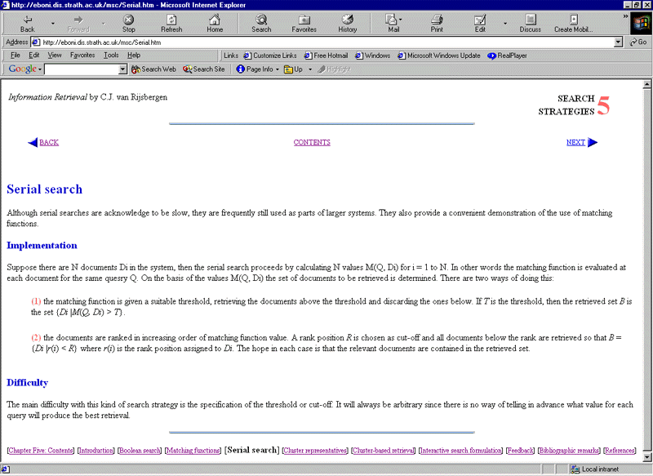
Figure 7. Example of clear layout: Information Retrieval by Keith van Rijsbergen, redesigned by Ruth Wilson

Guideline 8: Use short pages
“I don’t like scrolling”
Participant in EBONI psychology evaluation
Very long pages (for example, containing an entire chapter) are difficult to scan, and scrolling up and down to refer to different sections of text can be frustrating. Rather, dividing chapters into several pages can increase users’ intake of information. However, very short pages with little content which require the reader always to be continually “turning” pages can also be annoying and readers easily become lost. Therefore, consider the paper page as a model for the length of pages in an electronic book. In terms of logical structure, chapters should be divided according to natural breaks in the text (for example, one sub-section per page), and hypertext should be used to provide links between the pages.
Checkpoints
8.1 Create pages of a similar length to paper pages
8.2 Include links between pages
Example
This redesigned chapter of Hypertext in Context is divided into 8 separate sections according to headings used in the original text. The result is a series of short pages with hyperlinks between them. This is easier to scan for information than a chapter occupying just one long page.
Figure 8. Short page: Hypertext in Context by Cliff McKnight, Andrew Dillon and John Richardson, redesigned by Joan Dunn

Guideline 9: Provide content clues
“Everything’s labeled, everything’s got a heading and a sub-heading that tells you very specifically what that actual part is about”
Participant in EBONI psychology interview
Abstracts, keywords or tables of contents (linking to headings in the text) at the top of a page help readers to decide on the relevance of the contents of that page at a glance. By the same token, the inclusion of section headings, keywords or abstracts under chapter headings in the main table of contents (see Guideline 2), will inform the reader’s understanding of the contents of each chapter at a glance.
Checkpoints
9.1 Provide content summaries (in the form of abstracts, keywords or tables of contents) or each page
9.2 Position content summaries at the top of each page
Example
Drugs, Brains and Behaviour uses tables of contents at the top of each page. This provides clues about the content of the page and enables users to link directly to relevant sections.
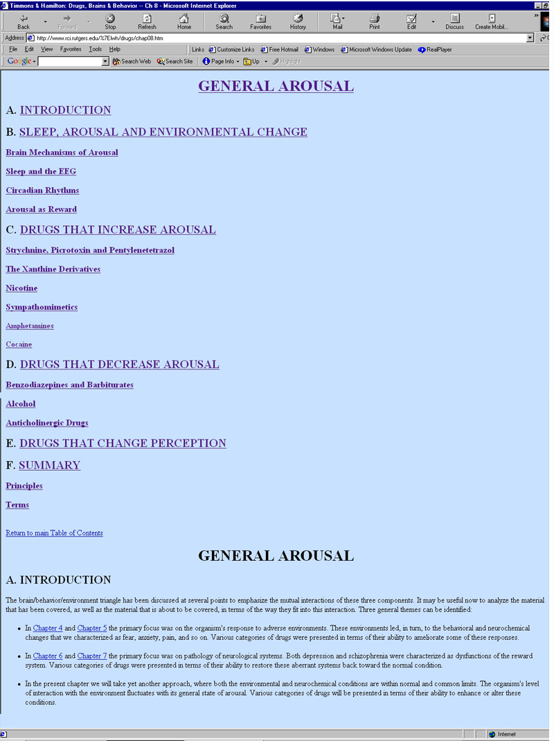
Figure 9. Content summary: Drugs, Brains and Behaviour by Robin Timmons and Leonard Hamilton

Guideline 10: Provide orientation clues
“I didn’t have any indication of where I was in the book”
Participant in EBONI hardware evaluation
Readers gain a sense of their place in a printed book via the page numbers and by comparing the thickness and weight of the pages read against the thickness and weight of the pages still to be read. It is important for this “sense of place” also to be present in the electronic medium; therefore, indications of a reader’s progress through the book should be accurate and visible.
Checkpoints
10.1 Provide indications of a reader’s place in the book
10.2 Make these indications accurate and visible
Accessibility considerations
Consult the following recommendation from the W3C Web Content Accessibility Guidelines 1.0:
- Guideline 12: Provide context and orientation information
Examples
In the Visual Book model, a sense of place was provided by presenting the electronic book in a form which closely resembled a paper book, with two pages displayed on screen at once, and the quantity of pages read and remaining to be read clearly visible.
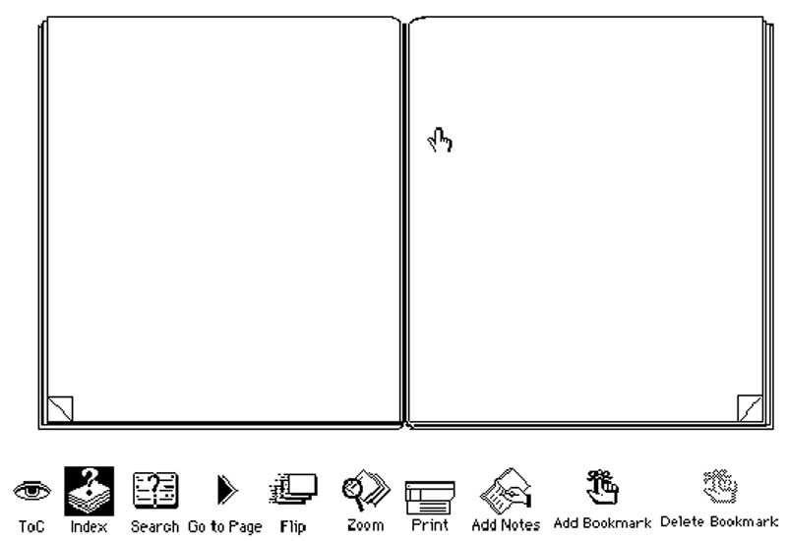
Figure 10.1. Orientation clues: The Visual Book
In the redesigned chapter of Hypertext in Context, a progress bar near the top of each page indicates the chapter and section currently being read.
Figure 10.2. Orientation clues: Hypertext in Context by Cliff McKnight, Andrew Dillon and John Richardson, redesigned by Joan Dunn

Guideline 11: Choose a readable font
“The text was too small”
Participant in EBONI psychology evaluation
Fonts should be large enough to read comfortably for long periods of time. If possible, readers would like to choose a font style and size to suit their individual preferences, thereby satisfying the needs of those with perfect vision and those with low vision or reading. Nielsen recommends sans-serif typefaces such as Verdana for small text, 9 points or less, since the low resolution of many monitors means that the detail of a serif font cannot be rendered fully. Choose a colour that contrasts sufficiently with the background.
Checkpoints
11.1 Use a font size large enough to read easily for a long time
11.2 Use sans-serif typefaces for small text
11.3 If possible, enable readers to manipulate font style and size
11.4 Use a colour that stands out from the background
11.5 Avoid italics
Example
This section of Neuroscience for Kids uses a 12 point serif font, with line lengths of 10 to 15 words.
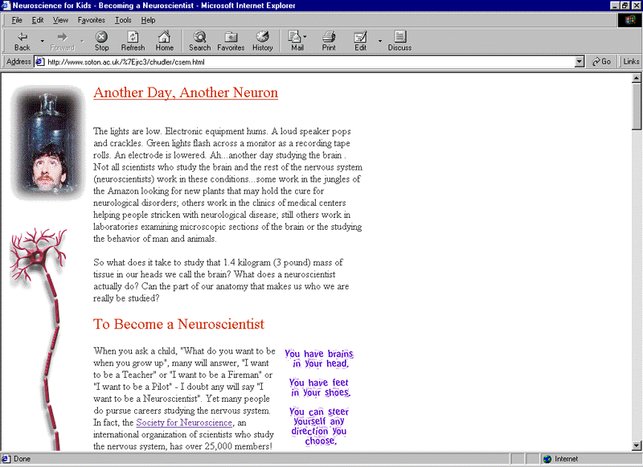
Figure 11. Readable font: Neuroscience for Kids by Eric Chudler

Guideline 12: Use colour to create a consistent style and aid scannability
“The white background – when I blink it’s like everything jumps out of the page and then goes back down again”
Participant in EBONI geography evaluation
Careful use of a few colours throughout can create a consistent style and increase the likeability and attractiveness of the book. Use of too many colours, however, can be distracting, and plain backgrounds should be used. Pure white backgrounds can “dazzle” readers, causing eye strain, and should be avoided.
Checkpoints
12.1 Use a few colours (e.g. for headings and bullet points) throughout
12.2 Use the same colours throughout
12.3 Use plain backgrounds
12.4 Do not use pure white backgrounds
Accessibility considerations
Consult the following recommendation from the W3C Web Content Accessibility Guidelines 1.0:
- Guideline 2: Don’t rely on colour alone
Example
This redesigned chapter of Information Retrieval uses the same colours throughout (blue for headings and forward and backward navigation icons, red for keywords and bullet points) to create a consistent, attractive style.
Figure 12. Consistent style: Information Retrieval by Keith van Rijsbergen, redesigned by Ruth Wilson

Guideline 13: Break text into short chunks
“Text was set out too much in a block – there was no breaking up of the text, e.g. by illustrations, photos. It al appeared a mass of words – not easy to read or follow”
Participant in EBONI pilot evaluation
Within each page, breaking the text into short chunks improves the scannability of the text. This can be achieved by, for example, interspersing text with images and diagrams and keeping paragraphs short, and by using meaningful sub-headings, indented, bulleted lists, and colour to break the uniformity of the text.
Checkpoints
13.1 Keep paragraphs short
13.2 Use meaningful-sub-headings
13.3 Use indented, bulleted lists
13.4 Use colour (e.g. for headings and bullet points)
13.5 Intersperse text with diagrams. Refer to Guideline 14 (“Use non-text items with care”) for advice on positioning diagrams.
Example
Neuroscience for Kids breaks text into short chunks by using lots of sub-headings and images, and by presenting paragraphs in coloured blocks.
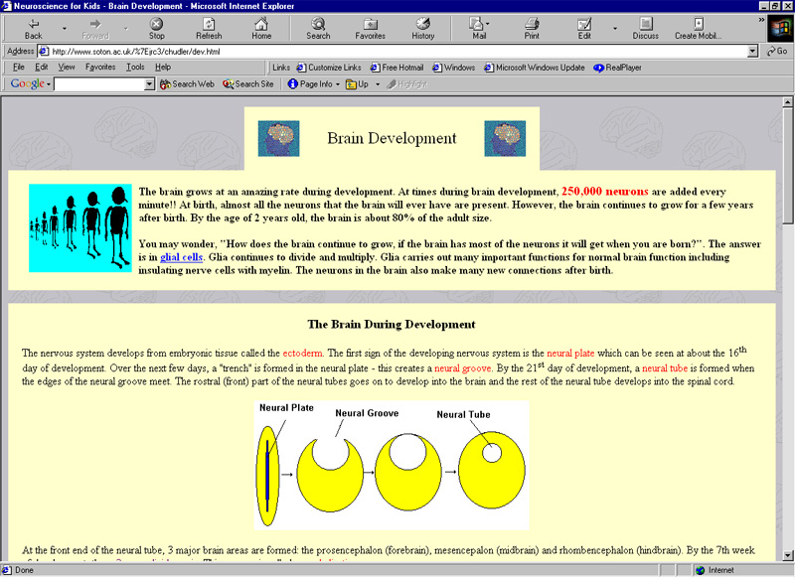
Figure 13. Text broken into short chunks: Neuroscience for Kids by Eric Chudler

Guideline 14: Use non-text items with care
“I like these pictures – they’re just like you get in a paper book!”
Participant in EBONI geography evaluation
Readers expect images, diagrams and formulae to be included and to look as visually sophisticated as they do on the printed page. If possible, pictures should be in colour. In scientific and mathematical disciplines, it is often necessary to study diagrams and formulae closely and to make comparisons, and this should be taken into account when positioning these items in the text. In such cases, it is advisable not only to insert images, diagrams and formulae within the main body of the text (this helps break the text into short chunks, as advised in Guideline 12), but also to allow the user to view enlarged versions in a separate window.
Checkpoints
14.1 Intersperse text with images, diagrams and formulae
14.2 Use high quality images and clear diagrams and formulae
14.3 Centre non-text elements so they stand out from the text
14.4 Allow users to open larger, more detailed, diagrams and formulae in separate windows
Accessibility considerations
Consult the following recommendations from the W3C Web Content Accessibility Guidelines 1.0:
- Guideline 1: Provide equivalent alternatives to auditory and visual content
- Guideline 5: Create tables that transform gracefully
Examples
Neuroscience for Kids uses lots of brightly coloured images to illustrate the text.
Figure 14.1. Use of images: Neuroscience for Kids by Eric Chudler
The redesigned chapter of Information Retrieval 34enters formulae and separates them from the text so that they stand out clearly.

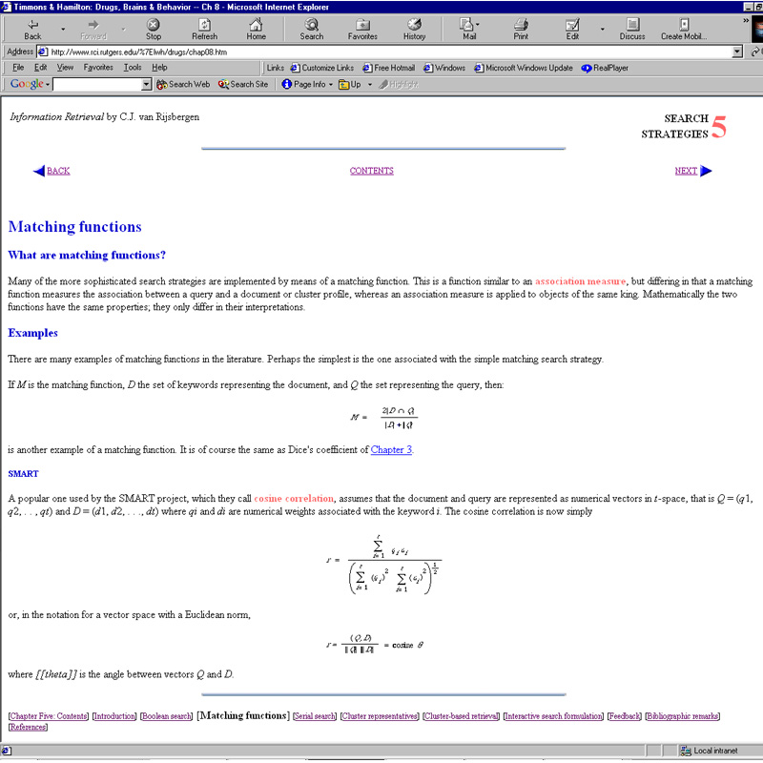
Figure 14.2. Use of formulae: Information Retrieval by Keith van Rijsbergen, redesigned by Ruth Wilson

Guideline 15: Use multimedia and interactive elements to engage users
“Multimedia content would enhance this encyclopaedia immensely”
Participant in EBONI encyclopaedia evaluations
Readers perceive one of the main advantages of presenting educational material in the electronic medium as being the ability to exploit multimedia elements such as video and audio, and interactive elements in the form of experiments and quizzes, all of which provide an effective alternative to print publications. Inclusion of elements such as these can increase a reader’s “sense of engagement” with the book, enhancing likeability and their ability to remember the information being conveyed. However, multimedia and interactive elements can make it more difficult to scan material in search of specific facts; therefore, textual equivalents for all information conveyed via these means should be provided (this is also good practice in terms of accessibility) and multimedia and interactive elements should be used to supplement and enhance, rather than replace, text.
Checkpoints
15.1 Include multimedia and interactive elements to supplement text
15.2 Provide textual equivalents
Accessibility considerations
Consult the following recommendations from the W3C Web Content Accessibility Guidelines 1.0:
- Guideline 1: Provide equivalent alternatives to auditory and visual content
- Guideline 6: Ensure that pages featuring new technologies transform gracefully
- Guideline 14: Ensure that documents are clear and simple (see, in particular, checkpoint 14.2 of the W3C Guidelines: “Supplement text with graphic or auditory presentations where they will facilitate comprehension of the page”)
Examples
Neuroscience for Kids exploits the capabilities of the electronic medium by offering a range of interactive learning activities.
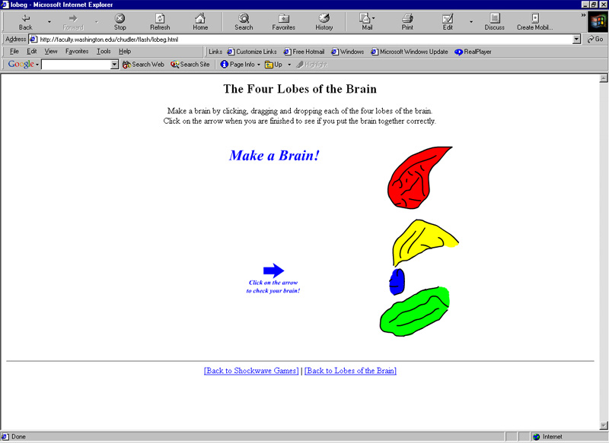
Figure 15.1. Use of interactive elements: Neuroscience for Kids by Eric Chudler
This example shows an interactive diagram of the eye, used in The Joy of Visual Perception. Clicking on different areas of the diagram provides information on different parts of the eye.
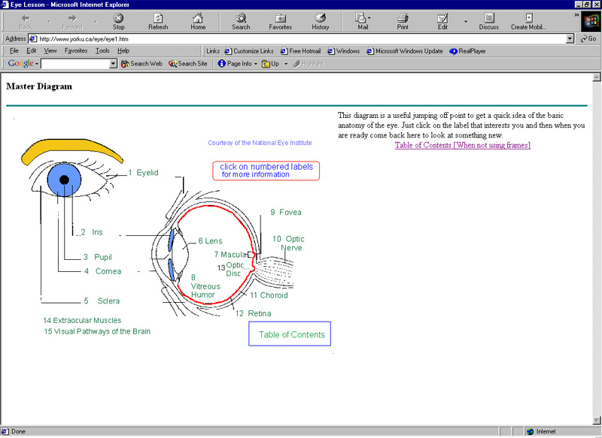
Figure 15.2. Use of interactive elements: The Joy of Visual Perception by Peter Kaiser

Guideline 16: Provide bookmarking, highlighting and annotating functions
“I’m used to reading and highlighting – I couldn’t do this”
Participant in EBONI psychology evaluation
Bookmarking, annotating and highlighting facilities, often supplied by commercial ebook reader software products, can be awkward, difficult or time-consuming to use. If such facilities are provided, they should be as powerful, straightforward and quick to use as possible. Users would also like to perform advanced functions using these features, such as searching across annotations, or generating lists of annotations for use in other applications.
Checkpoints
16.1 Ebook reader software should include powerful but simple-to-use bookmarking and annotating facilities
16.2 Bookmarking and annotating facilities should be powerful, flexible and capable of performing advanced functions
Example
The Visual Book model offered bookmarking and annotating functions which were simple to use.
Figure 16. Bookmarking and annotating functions: The Visual Book

Guideline 17: Enable customisation
“Font can only be changed between two modes: small and large. Have more choices!”
Participant in EBONI hardware evaluation
Readers appreciate the ability to customise a book according to their individual preferences. Aspects such as font style, size and colour should, where possible, be manipulable by the reader (although conforming by default to best practice). It should be possible for readers to save their preferred settings for continued use. Such functionalities are sometimes provided by commercial ebook products.
Checkpoints
17.1 Ebook reader software should enable customisation of text and background
17.2 It should be possible to save customized settings
17.3 Customisation functions should be visible and simple to implement
Example
Microsoft Reader (here running on a Hewlett-Packard Jornada 548) enables readers to choose between several different font sizes.
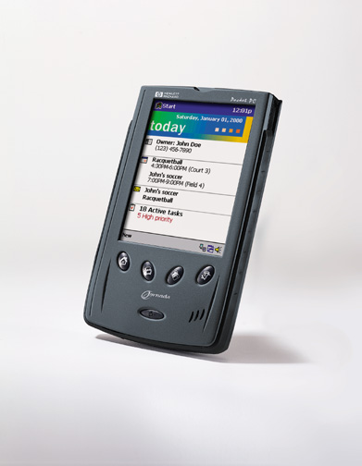
Figure 17. Microsoft Reader, available on the Hewlett-Packard Jornada 548, enables manipulation of font sizes
- Hardware design guidelines
During Summer 2001, EBONI researched the second factor affecting ebook usability: the hardware surrounding the content, which enables the user to interact with the book. Five portable devices were evaluated by lecturers and researchers at the University of Strathclyde: a Hewlett-Packard Jornada with Microsoft Reader, Franklin's eBookMan, a Palm Vx with Palm Reader, a Rocket eBook and a Softbook (now superseded by the REB 1100 and the REB 1200 respectively). Feedback indicated several design elements that can enhance or detract from the experience of reading or consulting an electronic book. These are outlined in the following five guidelines:
Guideline 18: Employ high quality display technology
“Looking at a screen for a long period is sore on the eyes”
Participant in EBONI psychology evaluation
Display technology should be high resolution, with high contrast and minimal glare; lower resolution monitors can cause eye-strain with prolonged use. Backlighting can increase portability, in that it enables text to be read in poor lighting conditions. In EBONI's hardware evaluations, users preferred the device with a colour screen and expressed desire for a colour screen where this was not available.
Checkpoints
18.1 Display technology should be high resolution
18.2 Display technology should be high contrast
18.3 Backlighting should be provided
18.4 Colour displays should be used
Example
The Hewlett-Packard Jornada 548 has a 2.9 x 2.1 inch high resolution backlit colour screen and runs Microsoft Reader. This attempts to recreate the look and feel of ink on paper through ClearType technology, which triples the resolution of text by smoothing the tiny spaces between the pixels on a computer screen.
Figure 18. High quality display technology: Hewlett-Packard Jornada 548

Guideline 19: Balance lightness and portability against legibility
“[The ebook] really needs to be made a lot lighter/more portable… I guess you are left with a dilemma – how do you preserve the size/format but make it more portable?”
Participant in EBONI hardware evaluation
Finding the optimum size of ebook hardware is a question of balancing weight, portability and ergonomics against legibility and quantity of text on screen. Small, slim, lightweight devices are easier to hold and more attractive than large and heavy ones; however, users dislike very small screens which restrict the amount of text displayed in any one "page", as they have to turn pages very frequently.
Checkpoints
19.1 Devices should be light
19.2 Screens should be large enough to contain a quantity of text similar to that of a paper book. However, this must not conflict with checkpoint 18.1 (devices should be small and light enough to hold in one hand).
Example
The Palm Vx, which runs a number of ebook software programs, has a 2.3 x 2.3 inch screen and weighs 4 oz, while the REB 1200 dedicated reader has an 8.2 inch (diagonal) screen and weighs 33 oz.
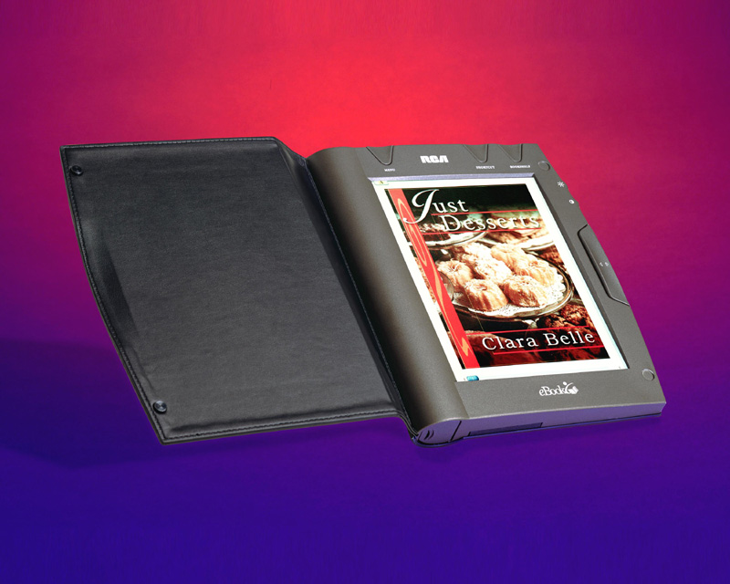
Figure 19. Large device: REB 1200
Guideline 20: Design devices for comfort
“Some effort had obviously been put into the ergonomics of the device, but it just didn’t feel right. I found myself constantly shifting it from hand to hand”
Participant in EBONI hardware evaluation
Ebook hardware should be designed for comfort (large, heavy devices can be difficult to hold), and the ability to hold a device easily in one hand is considered an advantage. The necessity to use a stylus should be kept to a minimum (they are awkward to handle, and users worry about losing them).
Checkpoints
20.1 Devices should be small and light enough to hold comfortably in one hand
20.2 The necessity to use a stylus should be kept to a minimum
Example
In EBONI's evaluations, the Jornada 548 was found to be comfortable to hold.
Figure 20. Designed for comfort: Hewlett-Packard Jornada 548

Guideline 21: Use buttons and dials to improve page turning
“The ability to change pages by using your thumb on the wheel meant that you could quickly move through a story without breaking your stride”
Participant in EBONI hardware evaluation
Careful design of buttons or dials for turning pages can improve this aspect of the paper book metaphor, leading to a smoother, faster transition from one page to the next. In EBONI's evaluations, users of the devices which employ dials commented that they felt they could read faster using this method of page turning. Simple "page forward/page back" buttons are felt to be intuitive, but buttons should be large, as opposed to small and fiddly.
Checkpoints
21.1 Dials or simple buttons should be used for page turning
21.2 Buttons should be large
Examples
The REB 1100 uses simple, large "page forward/page back" buttons.
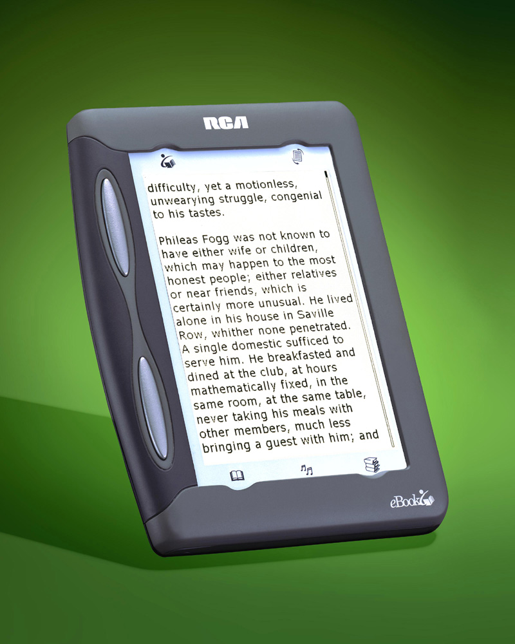
Figure 21.1. Buttons for page turning: REB 1100
Franklin's eBookMan has a dial at the side which can be used to turn pages.
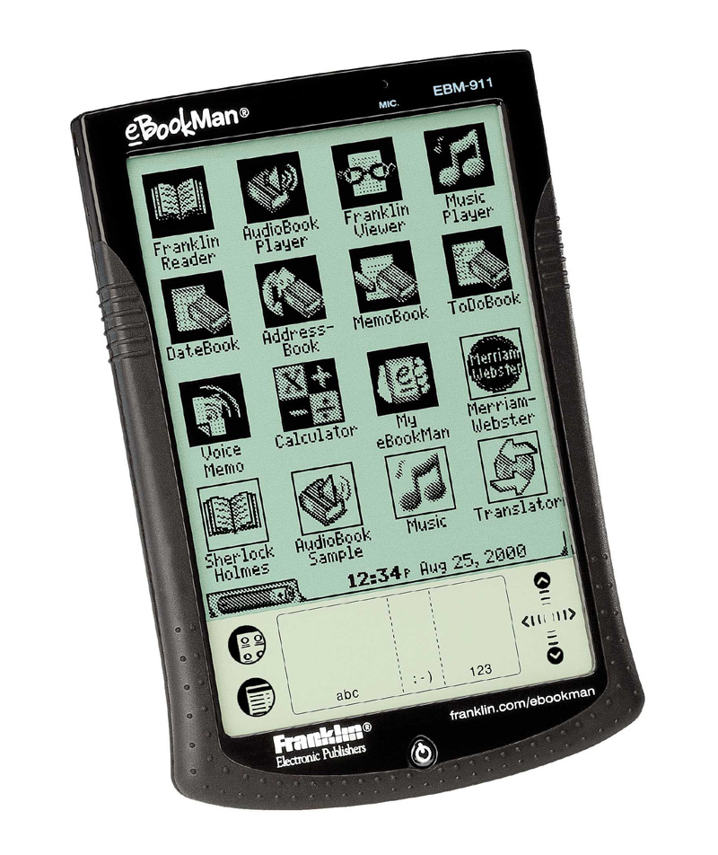
Figure 21.2. Dial for page turning: Franklin's eBookMan

Guideline 22: Make devices robust
“Try getting beach sand in that… Reading in the bath is out as well”
Participant in EBONI hardware evaluation
The number and diversity of situations in which ebooks can be read can be constrained when devices are delicate, fragile or costly. Most devices used in EBONI's evaluations were criticised for being too fragile and thereby restricting usage. Rubber edges and hard covers can help with this aspect of ebook design.
Checkpoint
22.1 Devices should be made robust via hard covers and rubber edges
Example
Franklin's eBookMan has rubber corners and a plastic flip cover (not shown in this picture).
Figure 22. Robust device: Franklin's eBookMan
Index
 | Page |  | Page
A |  | I
abstracts | 24 | icons | 17
annotations | 38 | images | 33
audio | 35 | index | 12
 |  | interactive | 35
B
backlighting | 41 | J
bookmarks | 38 | justification | 20
build | 49
bullet points | 32 | K
buttons | 46 | keywords | 24
C |  | L
colour | 30 | legibility | 29
colour screen | 41 | line length | 20
comfort | 44 | link colours | 17
contents, table of | 10 | links, external | 15
contrast | 41 | lists | 32
cover | 8
cross-referencing | 17 | M
customisation | 39 | monitor | 41
 |  | multimedia | 35
D
diagrams | 33 | N
dials | 46 | navigation | 17
display | 41
 |  | O
E |  | on-screen design | 8
ergonomics | 44 | orientation | 26
experiments | 5
external links | 15 | P
eye-strain | 41 | page length | 21
 |  | page turning | 44
F |  | pagination | 20
font | 29 | portability | 43
footnotes | 17 | preferences | 39
formulae | 33 | progress | 26
G |  | Q
glare | 41 | quizzes | 35
glossary | 17
 |  | R
H |  | reading speed | 46
hardware | 41 | references | 17
headings | 32 | resolution | 29
hypertext | 17
S |  | T
search | 13 | table of contents | 10
size | 43 | text equivalents | 33
speed of reading | 46 | turning pages | 46
stylus | 44 | typography | 20
sub-headings | 32
 |  | V
 |  | video | 35
 |  | W
 |  | weight | 43
 |  | white space | 20

Bibliography
Evaluation material
Chudler, Eric. Neuroscience for Kids. Available: http://faculty.washington.edu/chudler/neurok.html
The Columbia Encyclopaedia. Available: http://www.bartleby.com/65/
Encarta. Available: http://encarta.msn.com/reference/
Encyclopaedia Britannica. Available: http://www.eb.com/
Kaiser, Peter. The Joy of Visual Perception. Available: http://www.yorku.ca/eye/thejoy1.htm
McKnight, Cliff, Dillon, Andrew and Richardson, John. Hypertext in Context. Available: http://telecaster.lboro.ac.uk/HiC/HiC.html
McKnight, Cliff, Dillon, Andrew and Richardson, John. Chapter 5 of Hypertext in Context, redesigned by Joan Dunn. Available: http://ebooks.strath.ac.uk/eboni/hypertext/chaptercontents.html
van Rijsbergen, Keith. Information Retrieval. 2nd ed., 1979. Available: http://www.dcs.gla.ac.uk/Keith/Preface.html
van Rijsbergen, Keith. Chapter 5 of Information Retrieval. 2nd ed., 1979. Redesigned by Ruth Wilson. Available: http://ebooks.strath.ac.uk/eboni/ir/index.htm
Suler, John. The Psychology of Cyberspace. Available: http://www.rider.edu/users/suler/psycyber/psycyber.html
Timmons, C. Robin and Hamilton, Leonard W. Drugs, Brains and Behaviour. Available: http://www.rci.rutgers.edu/~lwh/drugs/
Accessibility references
DAISY Consortium. DAISY 2.02 Specification. Recommendation, 28 February 2001. Available: http://www.daisy.org/dtbook/spec/2/final/d202/daisy_202.html
W3C. HTML 4.0 Guidelines for Mobile Access. W3C Note, 15 March 1999. Available: http://www.w3.org/TR/NOTE-html40-mobile/
W3C. User Agent Accessibility Guidelines 1.0. W3C Candidate Recommendation, 12 September 2001. Available: http://www.w3.org/TR/2001/CR-UAAG10-20010912/uaag10.html
W3C. Web Content Accessibility Guidelines 1.0. W3C Recommendation, 5 May 1999. Available: http://www.w3.org/TR/WCAG10/

